**STl Report**

# Part (a)

# Scan 10 elements from the user, add the even in a queue, the odd in a stack.

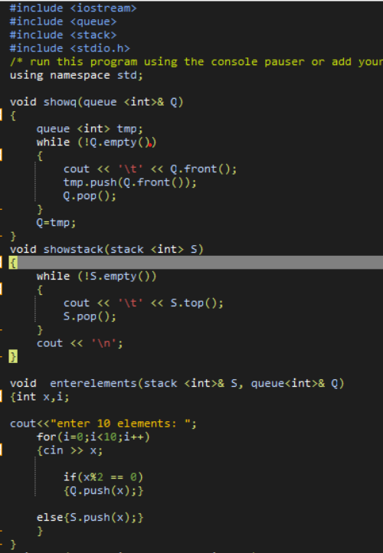

Using enterelements function user will input 10 numbers and will push the even numbers to the queue and the odd to the stack.

# Part (b)

# Print the sum of the even and odd numbers.

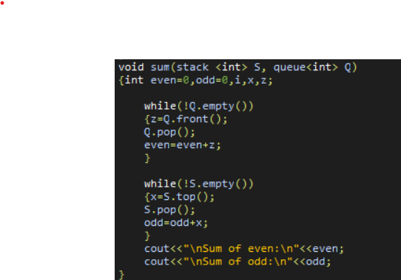

Using the sum function the sum of even and odd numbers is calculated .

No & is used because there is no need to have any changes that happened in the function in the main

# Part(c)

# Swap the elements of the stack by the elements of the queue.

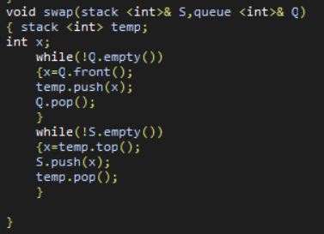

Using the swap function & is used so that the changes that happened will also be applied in the main

Swap of elements from queue to stack will require a temporary stack so is holds data from queue then swap the data from the temp stack to the stack we want then print the change.

# Print functions

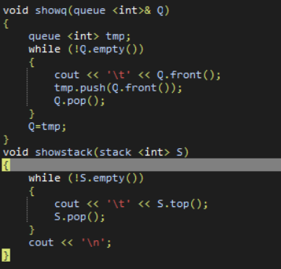

Main

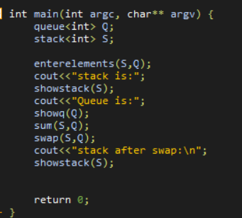

Code:

#include <iostream>

#include <queue>

#include <stack>

#include <stdio.h>

/* run this program using the console pauser or add your own getch, system("pause") or input loop */

using namespace std;

void showq(queue <int>& Q)

{

queue <int> tmp;

while (!Q.empty())

{

cout << '\t' << Q.front();

tmp.push(Q.front());

Q.pop();

}

Q=tmp;

}

void showstack(stack <int> S)

{

while (!S.empty())

{

cout << '\t' << S.top();

S.pop();

}

cout << '\n';

}

void enterelements(stack <int>& S, queue<int>& Q)

{int x,i;

cout<<"enter 10 elements: ";

for(i=0;i<10;i++)

{cin >> x;

if(x%2 == 0)

{Q.push(x);}

else{S.push(x);}

}

}

void sum(stack <int> S, queue<int> Q)

{int even=0,odd=0,i,x,z;

while(!Q.empty())

{z=Q.front();

Q.pop();

even=even+z;

}

while(!S.empty())

{x=S.top();

S.pop();

odd=odd+x;

}

cout<<"\nSum of even:\n"<<even;

cout<<"\nSum of odd:\n"<<odd;

}

void swap(stack <int>& S,queue <int>& Q)

{ stack <int> temp;

int x;

while(!Q.empty())

{x=Q.front();

temp.push(x);

Q.pop();

}

while(!S.empty())

{x=temp.top();

S.push(x);

temp.pop();

}

}

int main(int argc, char** argv) {

queue<int> Q;

stack<int> S;

enterelements(S,Q);

cout<<"stack is:";

showstack(S);

cout<<"Queue is:";

showq(Q);

sum(S,Q);

swap(S,Q);

cout<<"stack after swap:\n";

showstack(S);

return 0;

}